**Name:LOKESH**

**Date:02-03-2023**

**Task:2**

**1.Perform IP address spoofing:**

In IP spoofing, a hacker uses tools to modify the source address in the packet header to make the receiving computer system think the packet is from a trusted source, such as another computer on a legitimate network, and accept it. This occurs at the network level, so there are no external signs of tampering.

$ ifconfig eth0 192.168.209.15

$ ifconfig

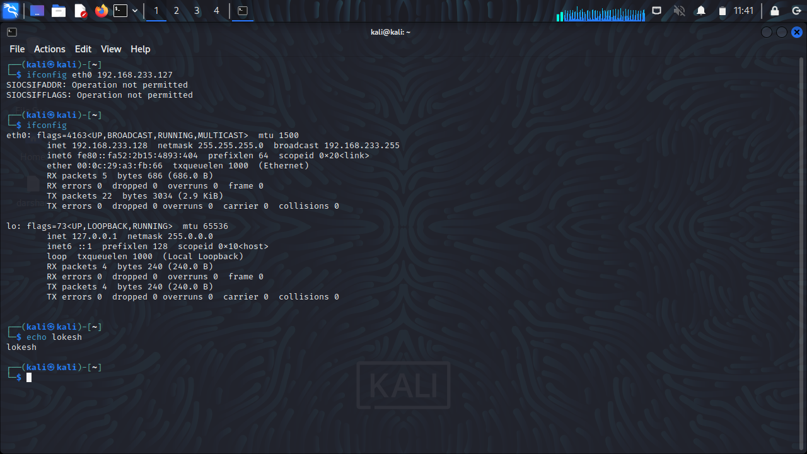

**2.Perform MAC address spoofing:**

An attacker can mimic your MAC address and redirect data sent to your device to another and access your data. A MAC spoofing attack is when a hacker changes the MAC address of their device to match the MAC address of another on a network in order to gain unauthorized access or launch a Man- in-the-Middle attack.

$ macchanger –s eth0

$ ifconfig

$ macchanger –r eth0

$ ifconfig eth0 down

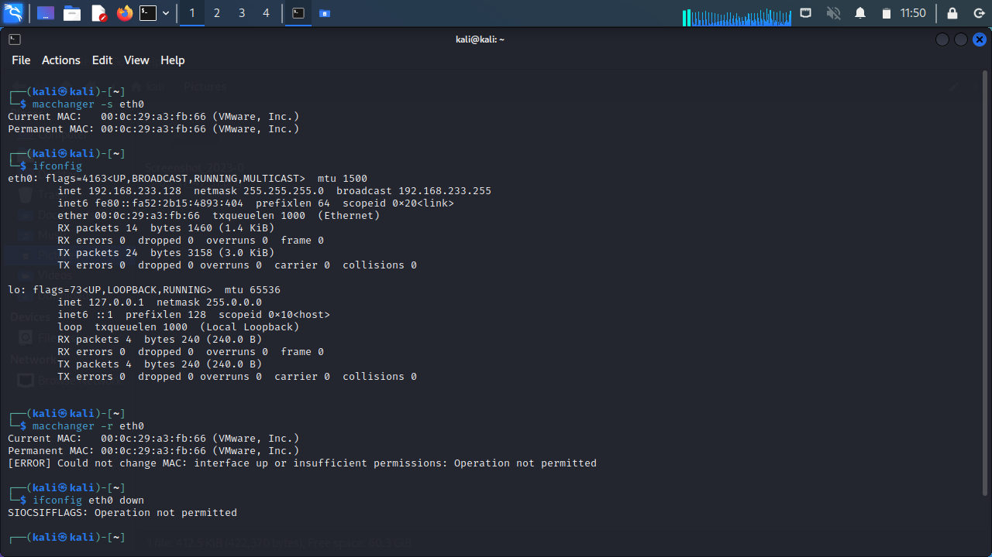

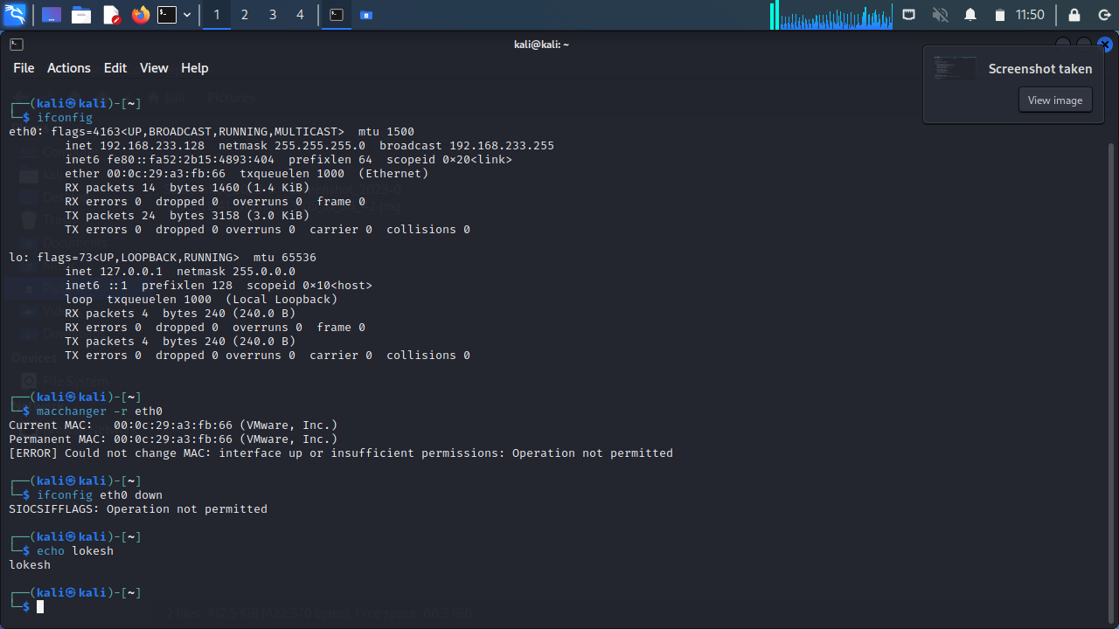

**3.Any 5 whatweb commands:**

**Basic scanning:**

The most basic command to scan a website with WhatWeb is:

$ whatweb mitkundapura.com 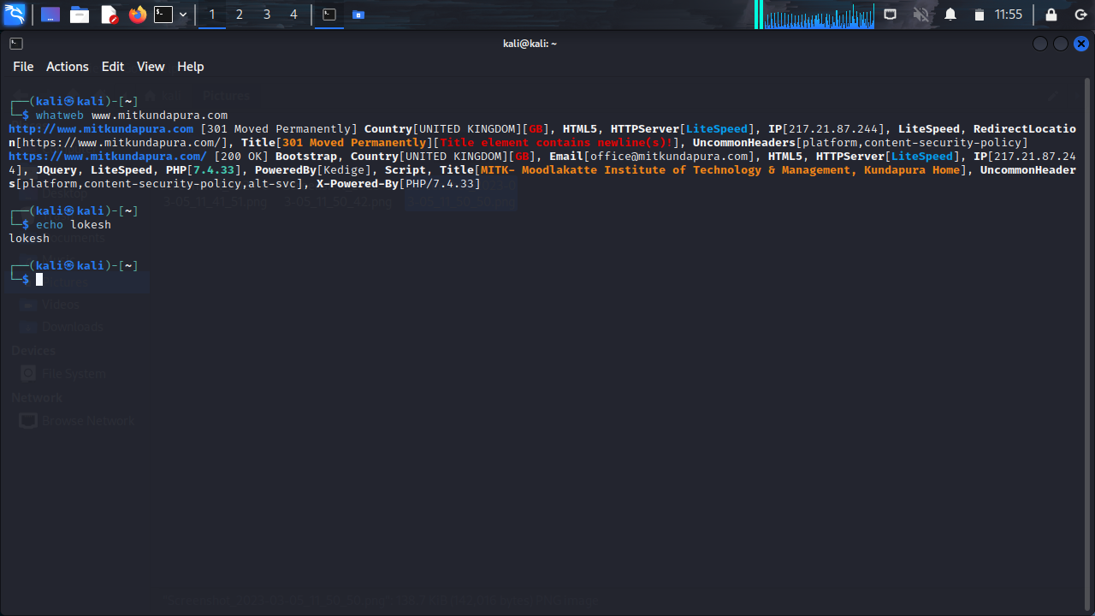

This will perform a default scan of the website and display the identified technologies.

**Verbose scanning:**

If you want more detailed information about the website, you can use the verbose flag (-v):

$ whatweb -v [website URL]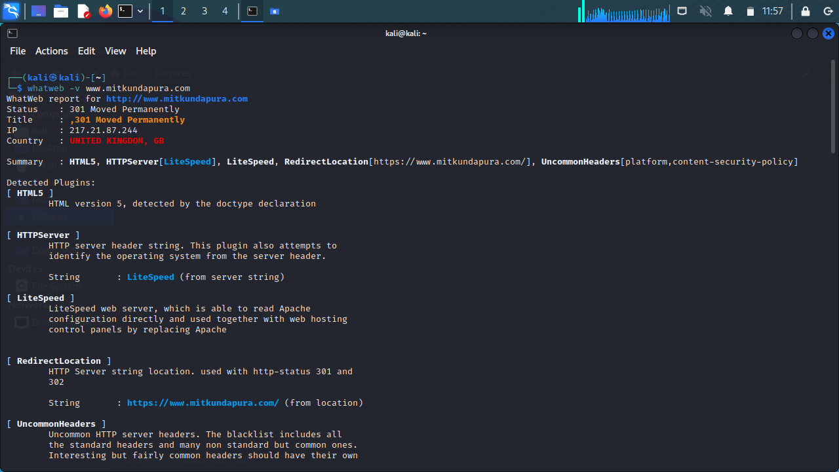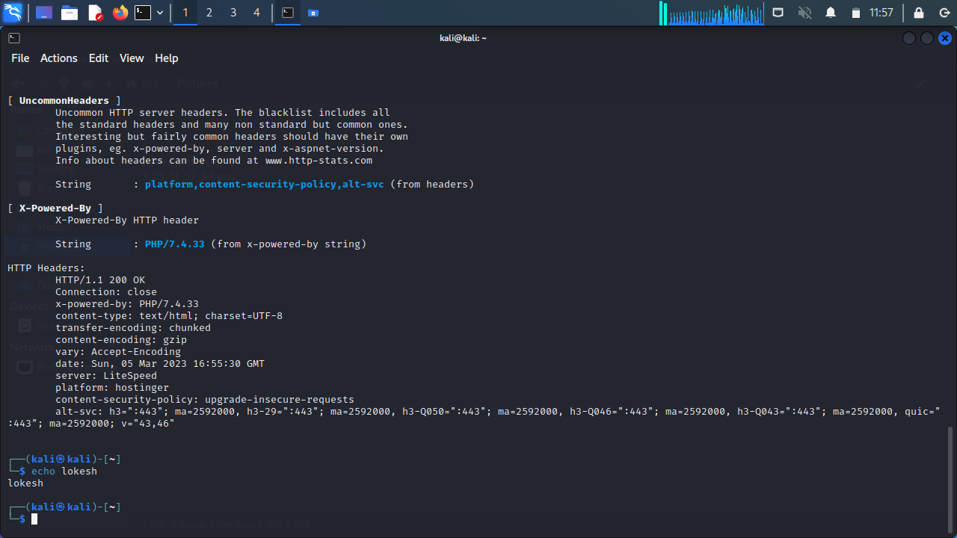

This will perform a more thorough scan and provide additional details, such as HTTP headers and server information.

$ whatweb –a 3 testfire.net

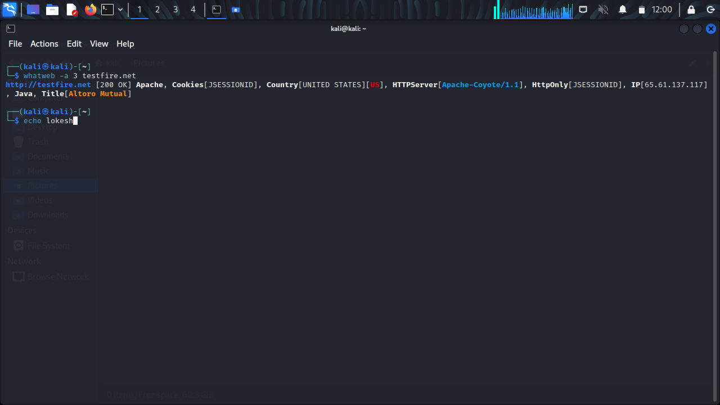

$ whatweb --max –redirect 2 testfire.net

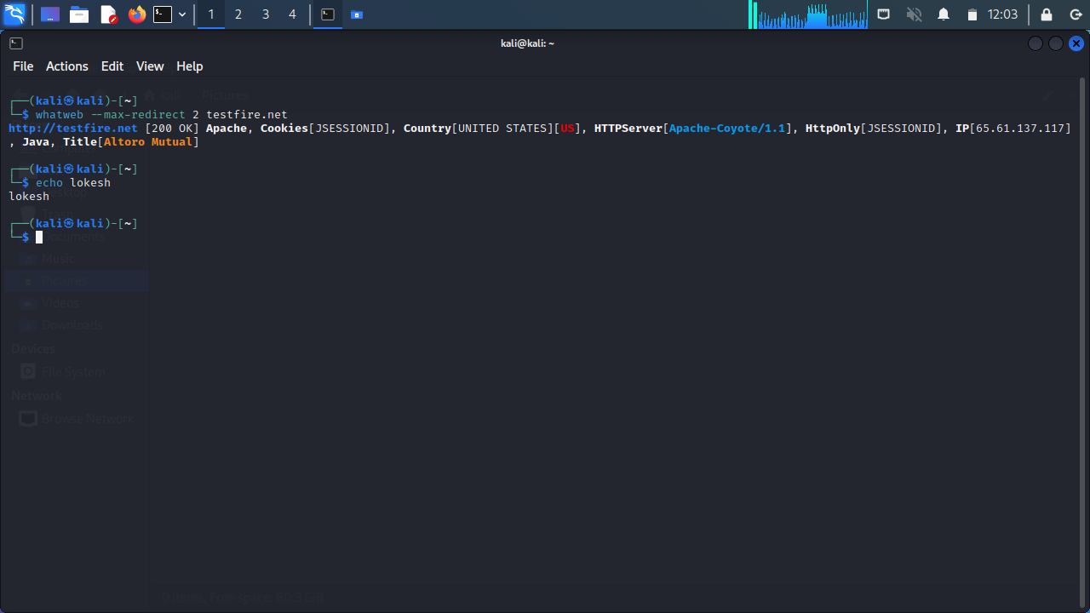

$ whatweb –v –a 3 testfire.net

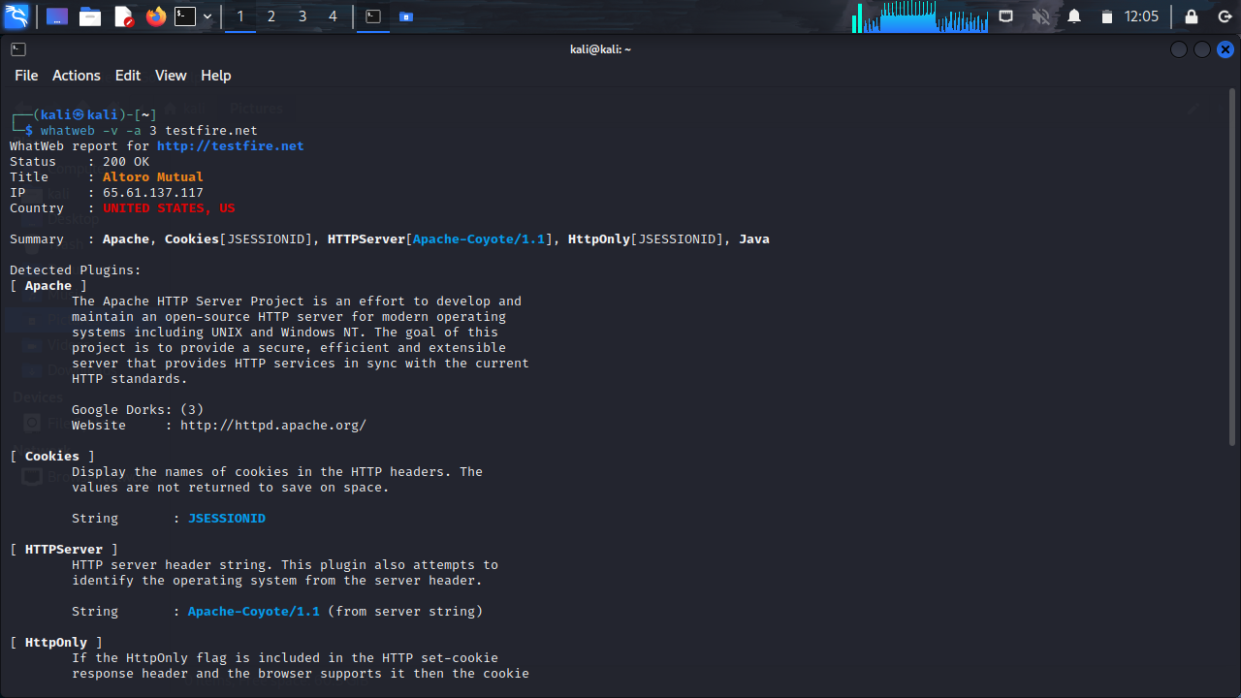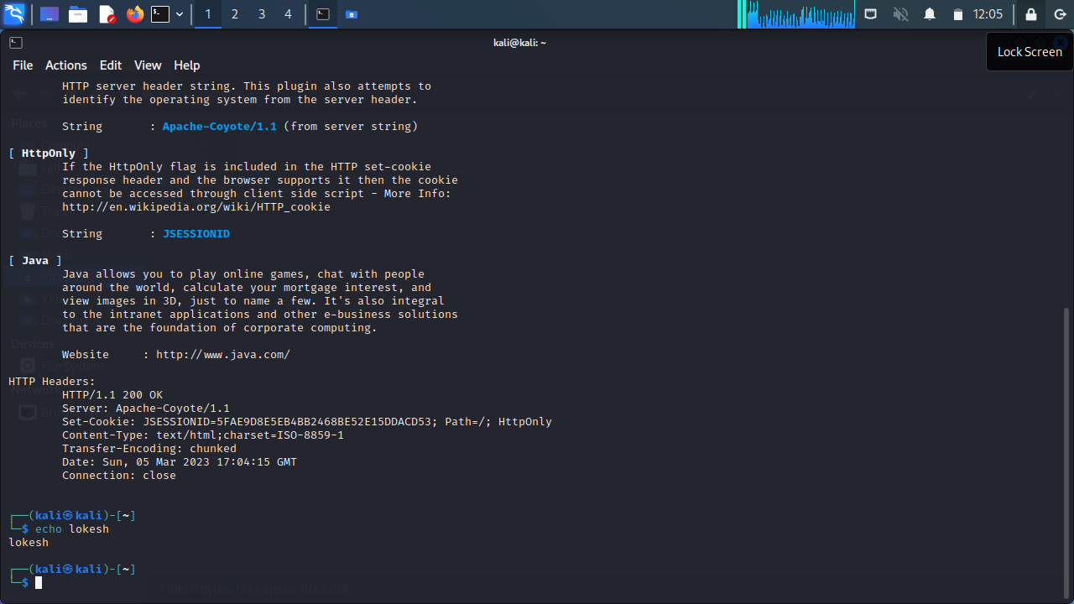

**4.Any 5 nslookup commands:**

$ nslookup google.com

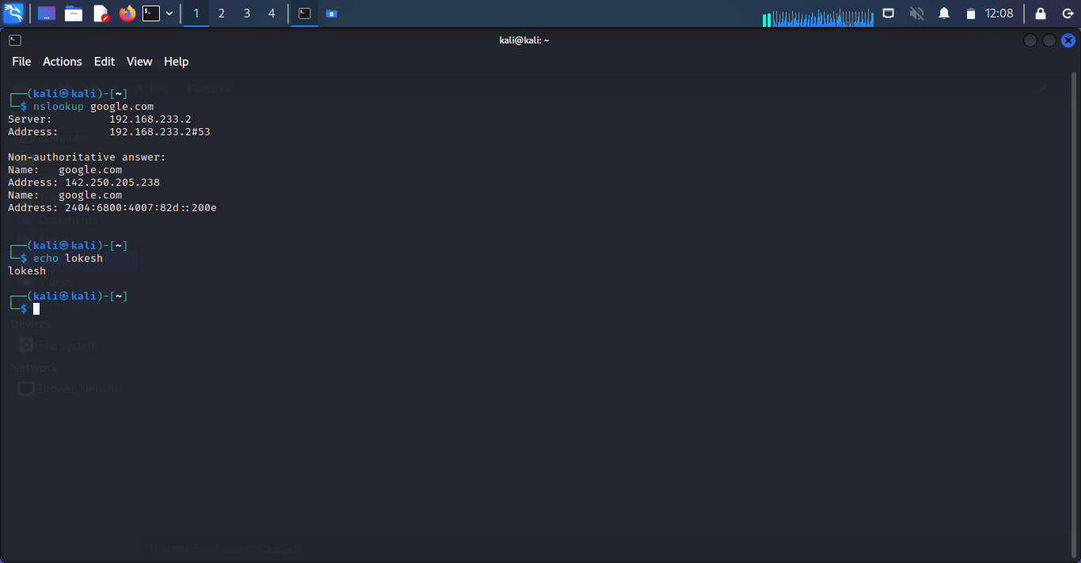

$ nslookup -type=mx example.com

This command will perform a DNS lookup for the mail exchange (MX) records associated with the domain name “example.com”.

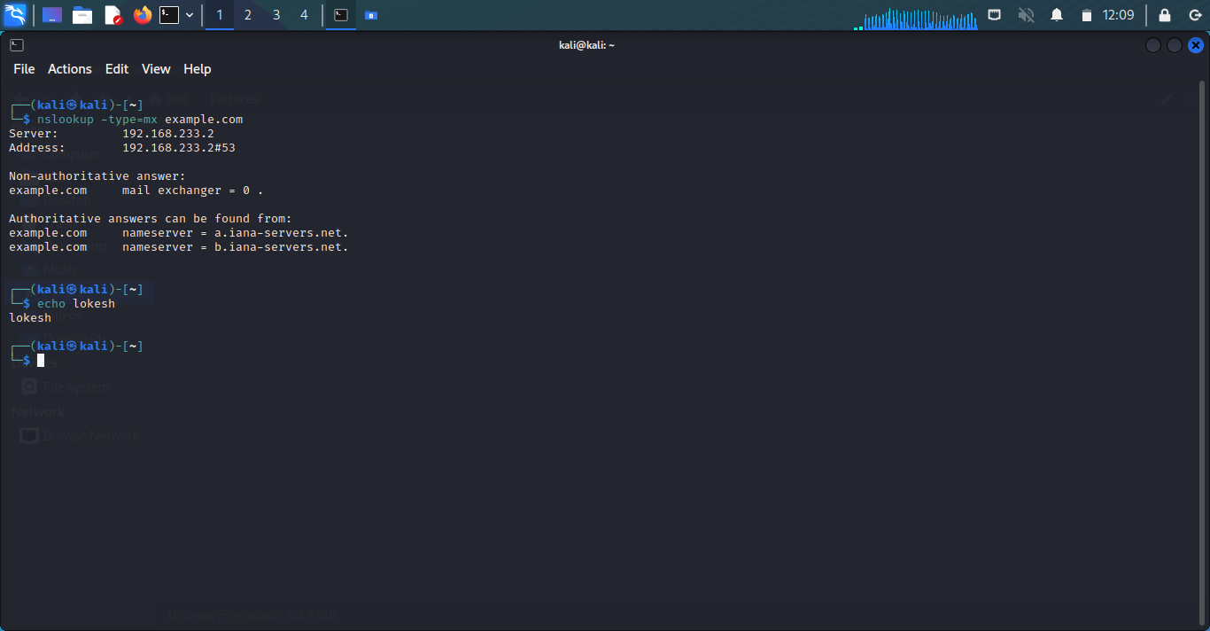

$ nslookup -type=ns example.com

This command will perform a DNS lookup for the name server (NS) records associated with the domain name “example.com”.

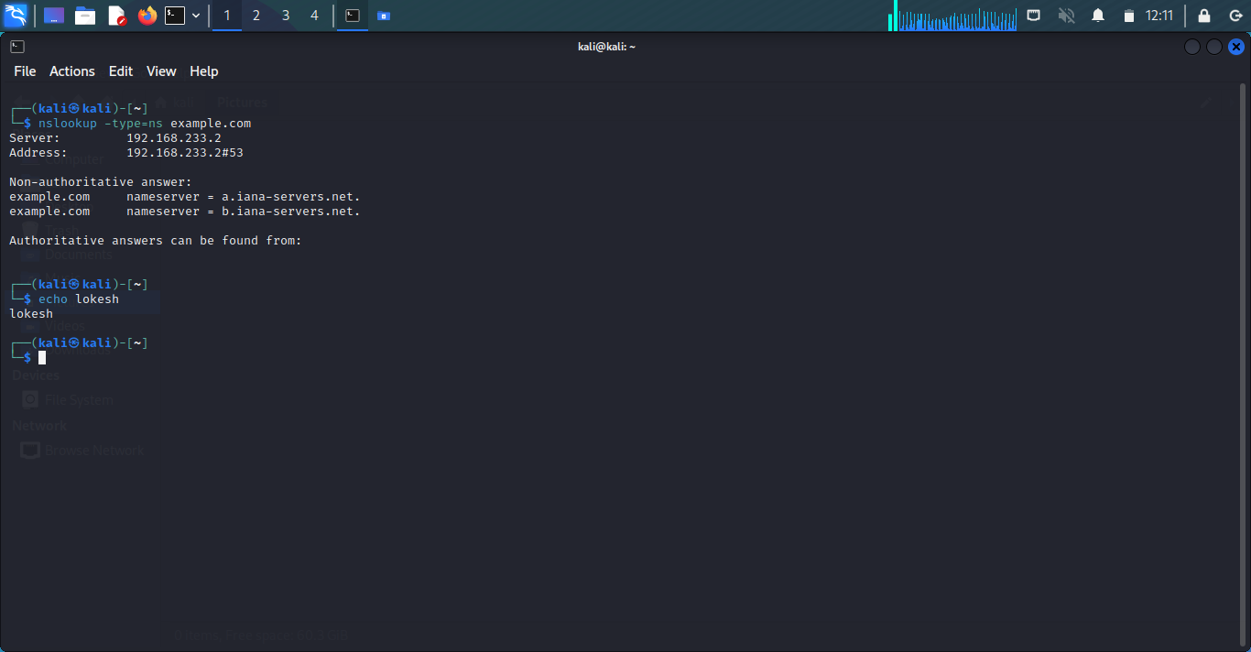

$ nslookup -type=a www.example.com

This command will perform a DNS lookup for the IPv4 address associated with the subdomain www.example.com.

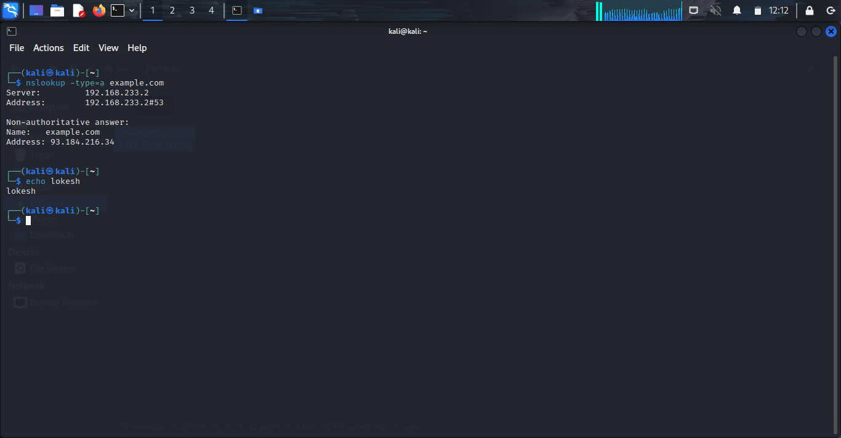

$ nslookup -type=a www.example.com

This command will perform a DNS lookup for the IPv6 address associated with the subdomain www.example.com

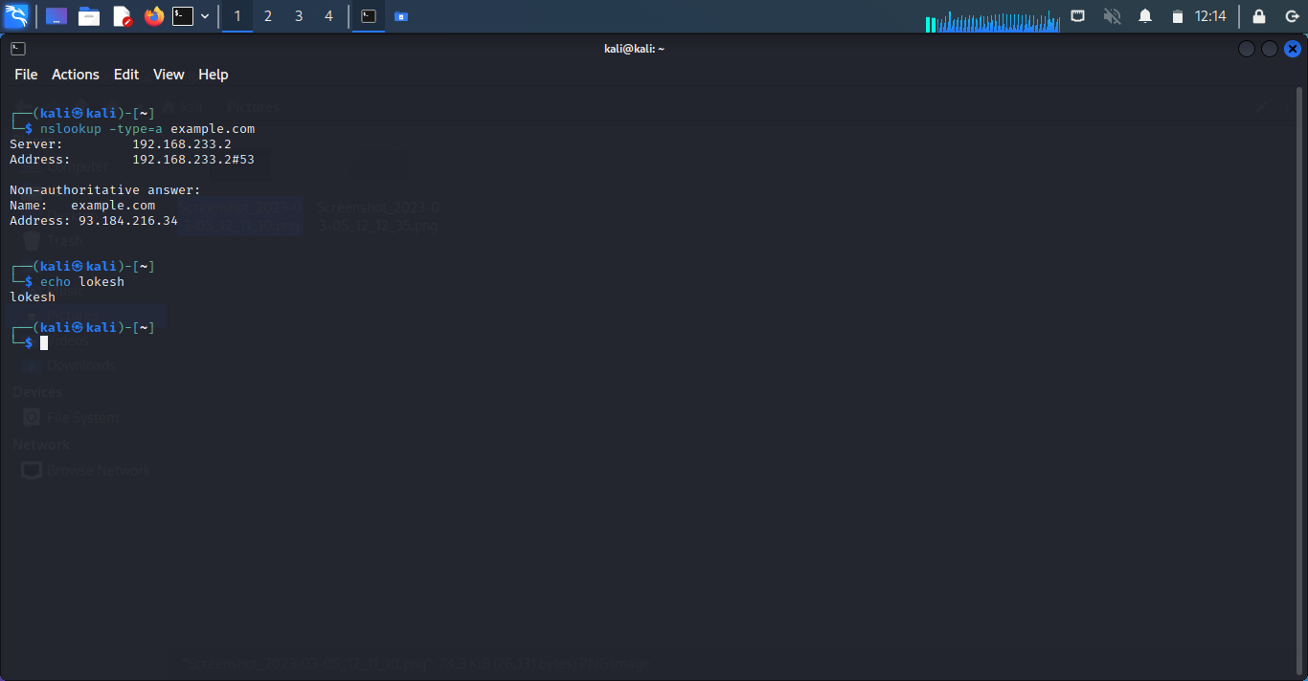

**5.whois Commands:**

The whois command is a protocol used to look up information about domain names, IP addresses, and other network-related information. Here are some common WHOIS commands:

$ whois mitkundapura.com

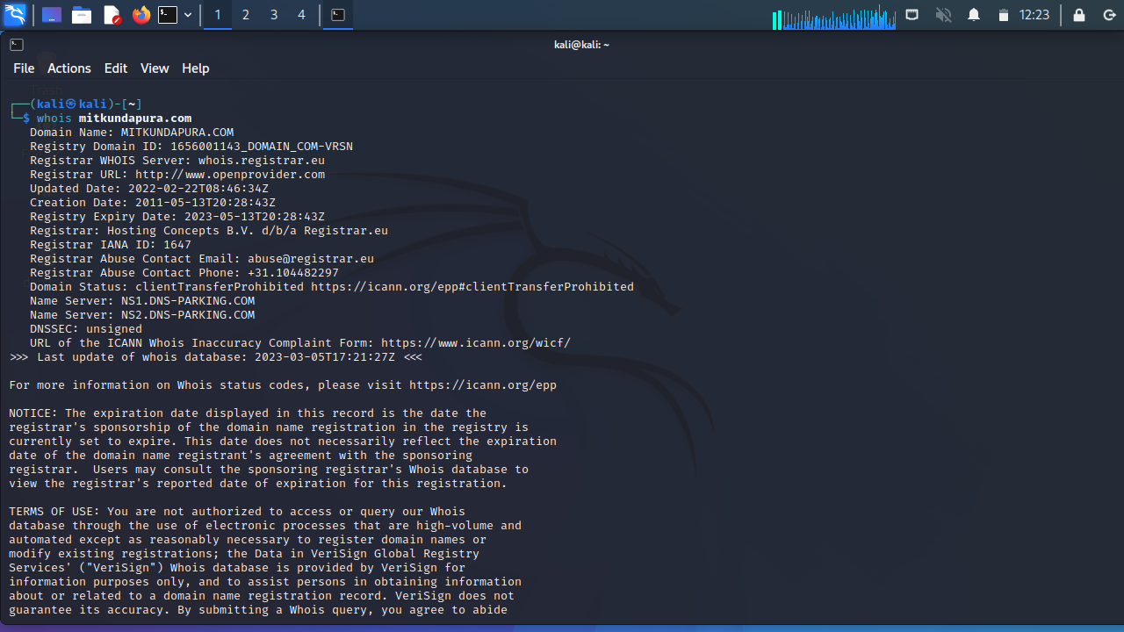

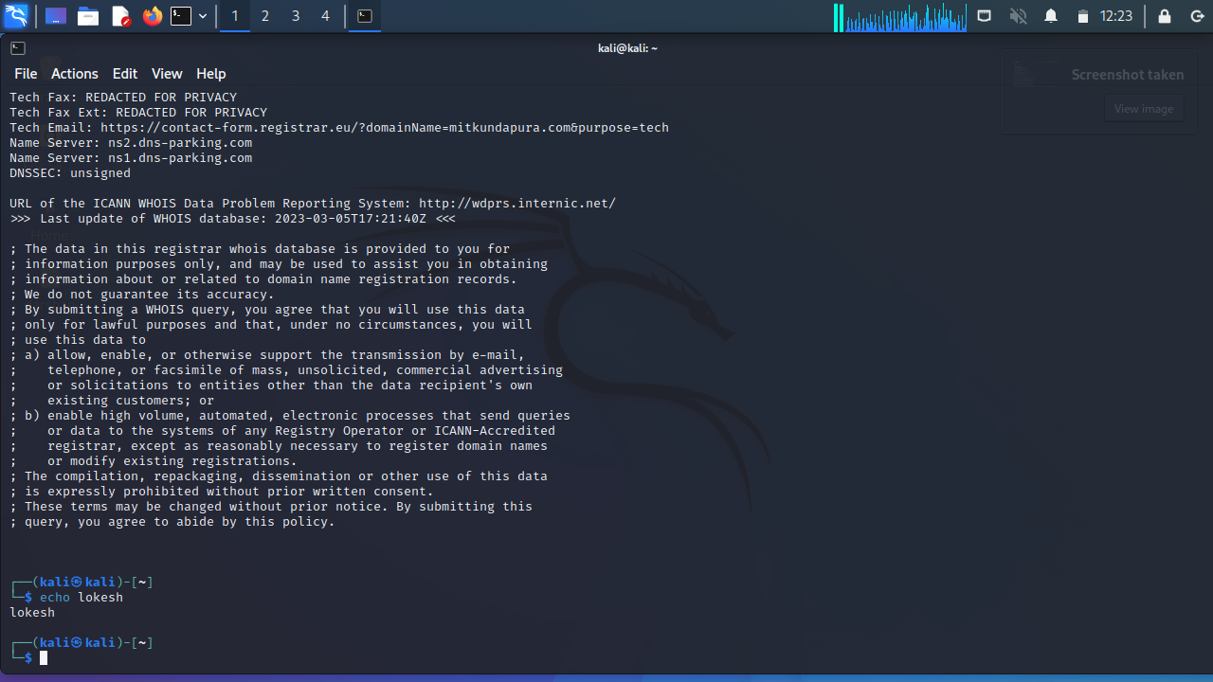

This command will display information about the domain name, such as the name of the registrant, the name servers, and the date of registration

**6.Find data packets using wireshark:**

You can easily find packets once you have captured some packets or have read in a previously saved capture file. Simply select Edit Find Packet... in the main menu. Wireshark will open a toolbar between the main toolbar and the packet list, "The "Find Packet" toolbar".

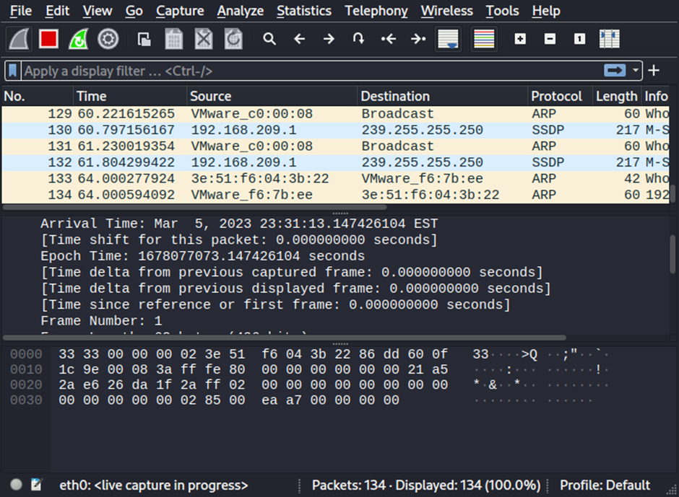

**7.Any 5 netdiscover command:**

Netdiscover is a network scanning tool used for discovering hosts and gathering information about them on a local network. Here are some of the basic commands:

$ netdiscover -i eth0

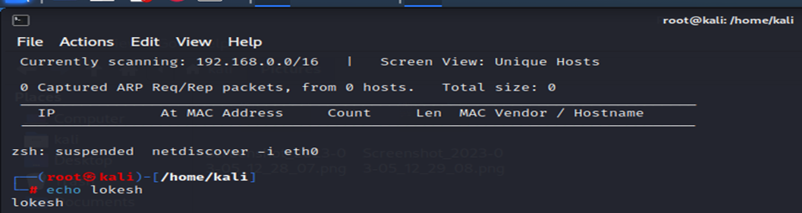

$ netdiscover -p

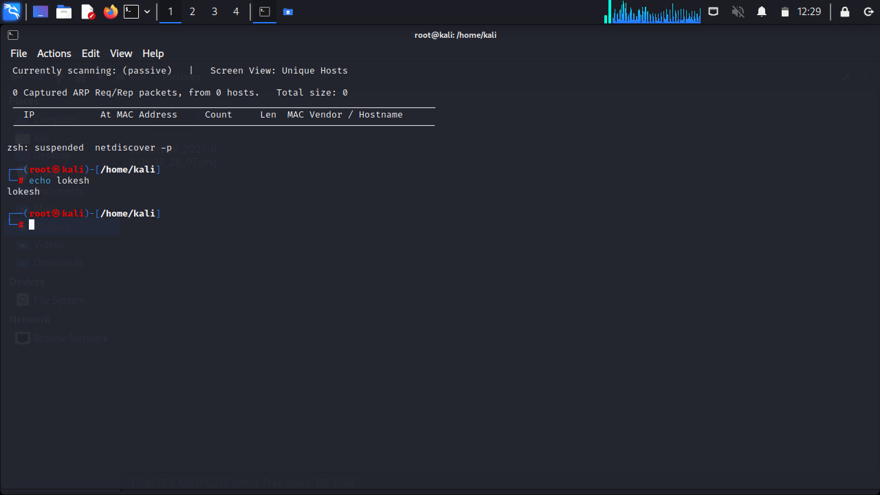

$ netdiscover -r 192.168.0.15

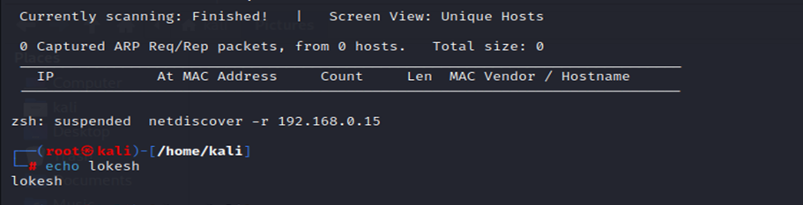

$ netdiscover -i eth0 -f

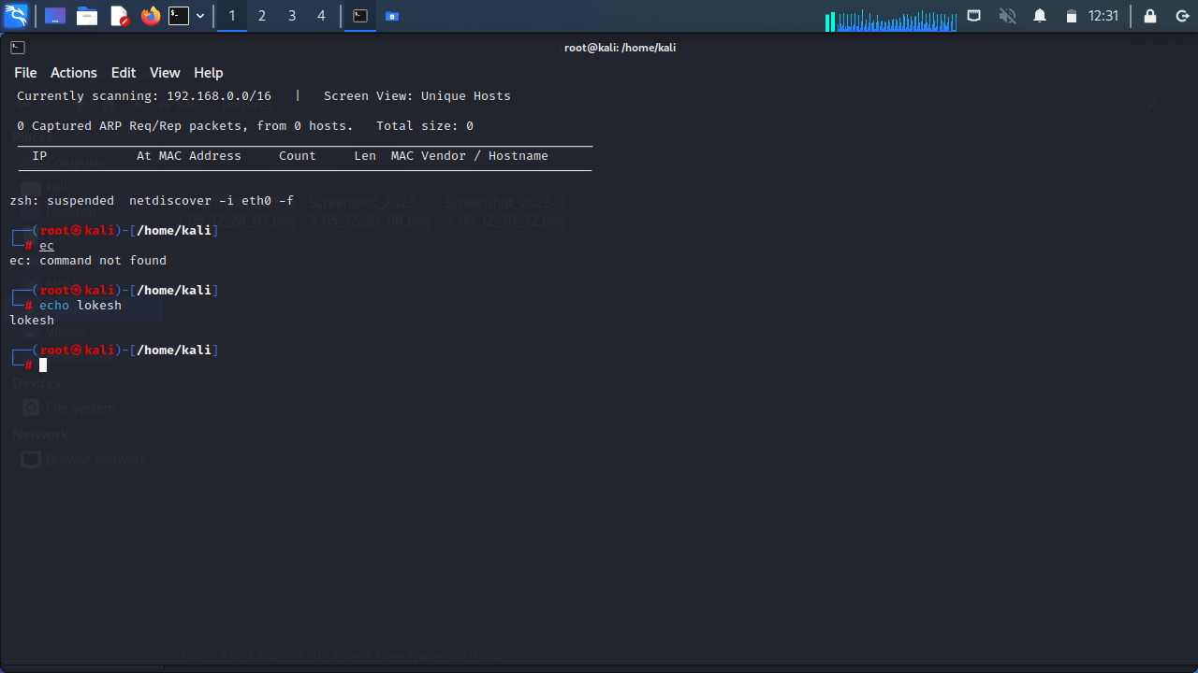

$ netdiscover –s 0.5

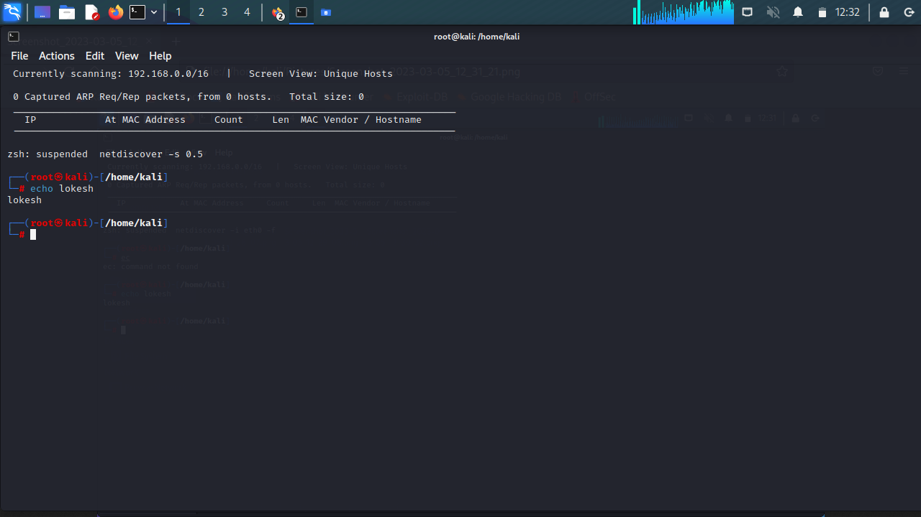

**8.CryptoConfiguration Flaw:**

CryptoConfiguration typically refers to the configuration of cryptographic protocols and algorithms used to protect sensitive data and communications.A flaw is context could refers to a weakness or vulnarabilty in the configuration that could that could potentially be exploited by the attackers.

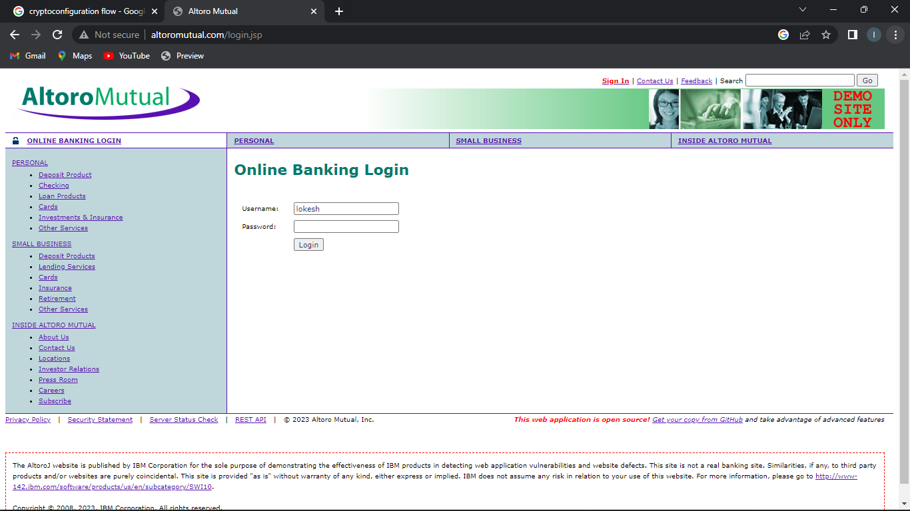

**9.Nikto commands:**

Nikto is a popular web server scanner that can help you identify potential vulnerabilities on a web server. Here are some common Nikto commands:

$ nikto -host kali.org

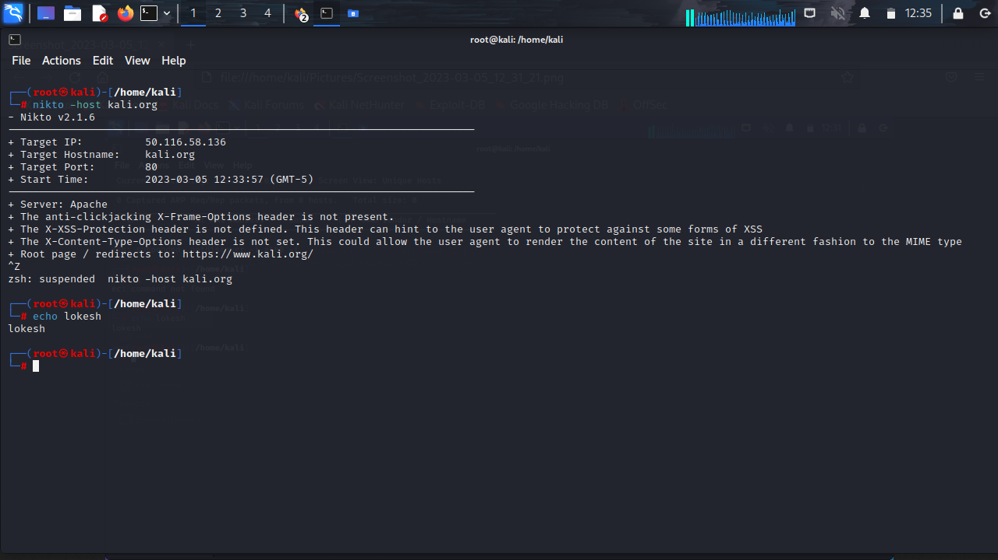

**10.Find Xml pages in website using dirbuster**

DirBuster is a multi threaded java application designed to brute force directories and files names on web/application servers. Often is the case now of what looks like a web server in a state of default installation is actually not, and has pages and applications hidden within. DirBuster attempts to find these. DirBuster searches for hidden pages and directories on a web server. Sometimes developers will leave a page accessible, but unlinked. DirBuster is meant to find these potential vulnerabilities. This is a Java application developed by OWASP.

